Report

Using Havij for SQL injection

In this task we are a hacking tool called havij for SQL injection attack on <http://testphp.vulnweb.com> website as a demo attack. SQL injection is an attack by which we can see, edit and delete data in a database of a website.

In this we have first downloaded the Havij tool from internet and while using this keep in mind disable all the firewalls because it is a dangerous tool so it shows virus or malware found.

In this URL there is no id=value so search the website for it.

Then paste it in the havij’s target.

Then analyze.

It will start the process of SQL injection.

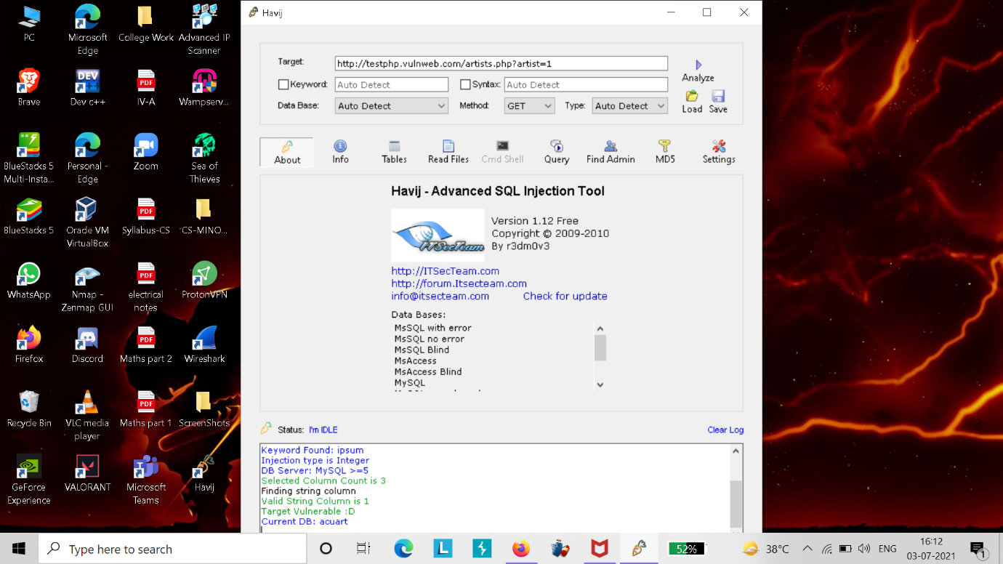

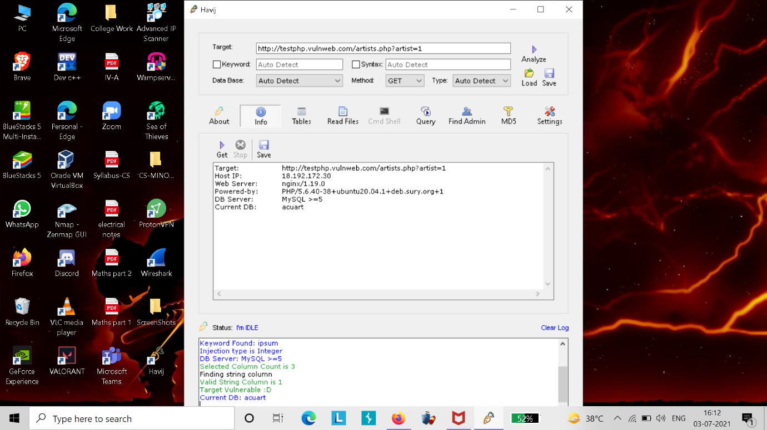

Here above is the information.

Next click on DB and then get DB(Database).

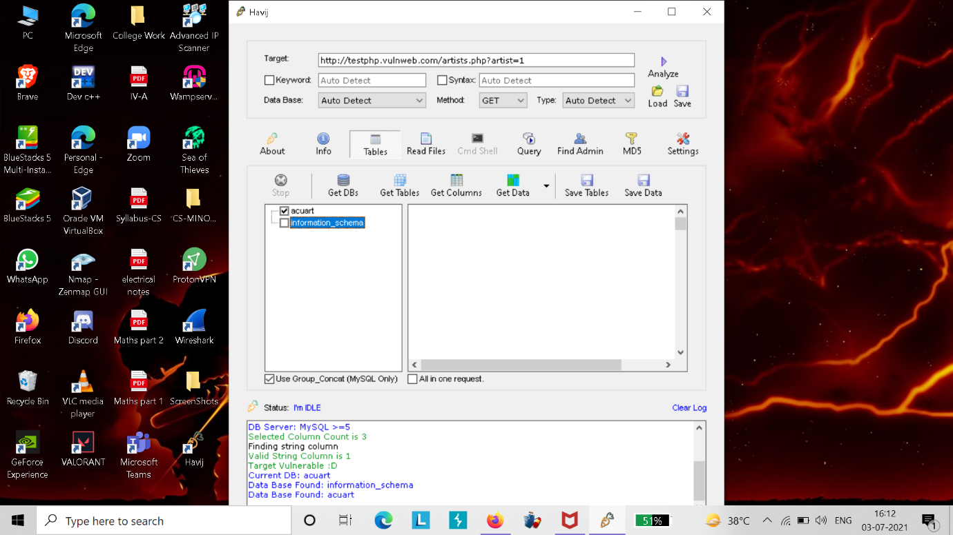

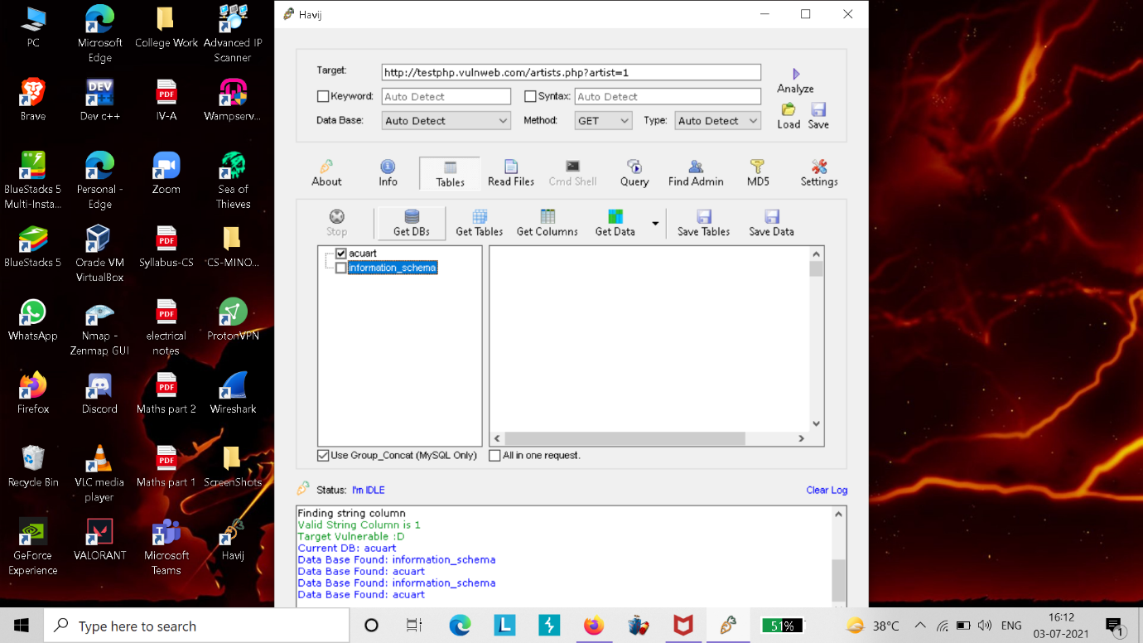

Some Ways to prevent SQL injections are: -

* Raise virtual and physical firewalls.
* Deny extended URLs.
* Enforce best practices for account and password.
* Don’t trust any user input.
* Scan regularly.
* Keep your system, apps and anti-virus softwares updated.